COSC 4P14
Assignment 1

  - Suppose users share a 2 Mbps link. Also suppose each user transmits continuously at 1 Mbps when transmitting, but each user transmits only 20 percent of the time. (Refer the discussion of statistical multiplexing).[15]
- When circuit switching is used, how many users can be supported?
Since each user requires 1 Mbps on the shared 2 Mbps link, 2 Mbps / 1 Mbps = 2 Users. Thus, 2 users can be supported.
- For the remainder of this problem, assume that packet switching is used. Why will there be essentially no queueing delay before the link if two or fewer users transmit at the same time? Why will there be a queueing delay if three users transmit at the same time?
Since the link is 2 Mbps, two users transmitting 1 Mbps at the same time does not exceed the bandwidth of the link (1 Mbps + 1 Mbps !> 2 Mbps) thus no queueing delay is required prior to the link because the link can handle both transmissions immediately. With three users transmitting 1 Mbps simultaneously, suddenly the bandwidth of the link is exceeded (1 Mbps + 1 Mbps + 1 Mbps = 3 Mbps > 2 Mbps), necessitating a queuing delay prior to the link.
- Find the probability that a given user is transmitting
It is stated in the problem description that each user transmits only 20% of the time, so the probability p that a given user is transmitting is 0.2.
- Suppose now there are three users. Find the probability that at any given time, all three users are transmitting simultaneously. Find the fraction of time during which the queue grows.
This can be solved via the binomial distribution formula:
$$p\left(n\right)= \left({m \atop n}\right)*p^{n}*{\left(1-p\right)}^{m-n}$$
$$p\left(3\right)= \left({3 \atop 3}\right)*p^{3}*{\left(1-p\right)}^{3-3}$$
Where: m = total # users = 3
n = # users to test for = 3
$\left({m \atop n}\right)$ = # of ways we can choose n users from m users -> $\left({3 \atop 3}\right)=1$
$p^{n}$ = probability of n users transmitting simultaneously -> ${(0.2)}^{3}$ = 0.008
${\left(1-p\right)}^{m-n}$ = probability of all other uses not being chosen
-> ${(1-p)}^{3-3}$ = ${(1-p)}^{0}$ = 1
Thus:
$$p\left(3\right)= \left({3 \atop 3}\right)*p^{3}*{\left(1-p\right)}^{3-3}$$
$$p\left(3\right)=\left(1\right)*\left(0.008\right)*(1)$$
$$p\left(3\right)=0.008$$
Therefore, the probability that all three users are transmitting simultaneously at any given time is 0.008. Since the queue only grows when the amount of data being transmitted is greater than the bandwidth of the link, it would require all three users to be transmitting simultaneously to make this happen, thus the fraction of time during which the queue grows is also 0.008.

  - Perform a Traceroute between source and destination on the same continent at three different hours of the day. [15]
For this question, I performed a traceroute from my local computer (North America) to www.google.com (North America).
- Find the average and standard deviation of the round-trip delays at each of the three hours.
8:23pm
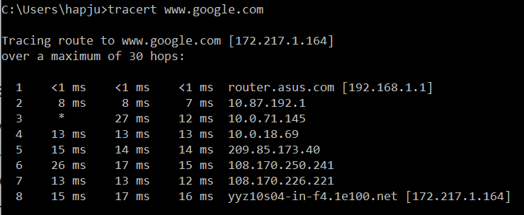
9:36pm
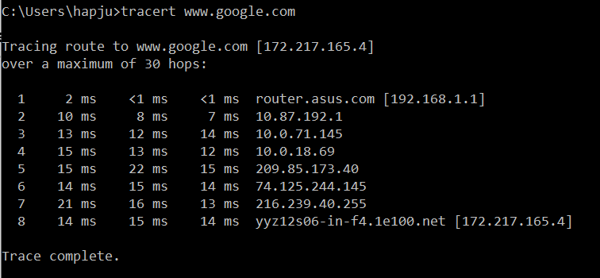
10:40pm
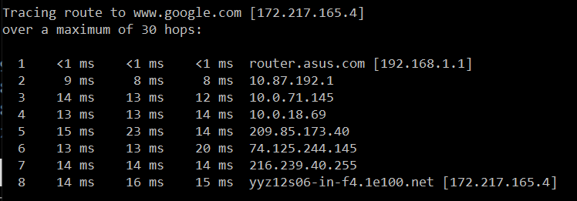

The averages (means) for the round-trip delays for hours 1, 2, and 3 are 16.0ms, 14.33ms, and 15.0ms (respectively).
$$µ_{1}=\frac{15+17+16}{3}=16.0ms$$
$$µ_{2}=\frac{14+15+14}{3}=14.33ms$$
$$µ_{3}=\frac{14+16+15}{3}=15.0ms$$

The standard deviations for the round-trip delays for hours 1, 2, and 3 are 0.816ms, 0.471ms, and 0.816ms (respectively).
$$σ=\sqrt{\frac{1}{N}\sum_{i=1}^{N}{{\left(x_{i}-µ\right)}^{2}}}$$
$$σ_{1}=\sqrt{\frac{\left[{\left(15-16\right)}^{2}+{\left(17-16\right)}^{2}+{\left(16-16\right)}^{2}\right]}{3}}= \sqrt{\frac{1+1+0}{3}}=\sqrt{\frac{2}{3}}≅0.816ms$$
$$σ_{2}=\sqrt{\frac{\left[{\left(14-14.33\right)}^{2}+{\left(15-14.33\right)}^{2}+{\left(14-14.33\right)}^{2}\right]}{3}}= \sqrt{\frac{0.1089+0.4489+0.1089}{3}}=\sqrt{\frac{0.6667}{3}}≅0.471ms$$
$$σ_{3}=\sqrt{\frac{\left[{\left(14-15\right)}^{2}+{\left(16-15\right)}^{2}+{\left(15-15\right)}^{2}\right]}{3}}= \sqrt{\frac{1+1+0}{3}}=\sqrt{\frac{2}{3}}≅0.816ms$$

- Find the number of routers in the path at each of the three hours. Did the paths change during any of the hours?
The number of routers in the path at each of the three hours is 8. Not only did the path change between traceroutes 1 and 2 (between 8:23pm and 9:36pm), but the IP address of the destination (www.google.com) also changed. The path did not change between traceroutes 2 and 3.
- Try to identify the number of ISP networks that the Traceroute packets pass through from source to destination. Routers with similar names and/or similar IP addresses should be considered as part of the same ISP. In your experiments, do the largest delays occur at the peering interfaces between adjacent ISPs?
The number of ISP networks that the traceroute packages passed through in my experiments were approximately 4 for traceroute 1, and 5 for traceroutes 2 and 3. Yes, it does appear that the largest delays occur at the peering interfaces between adjacent ISPs within my experiments.

- Repeat the above for a source and destination on different continents. Compare the intra-continent and inter-continent results.
Traceroute from local (North America) to www.bbc.net.uk (Europe)
8:31pm
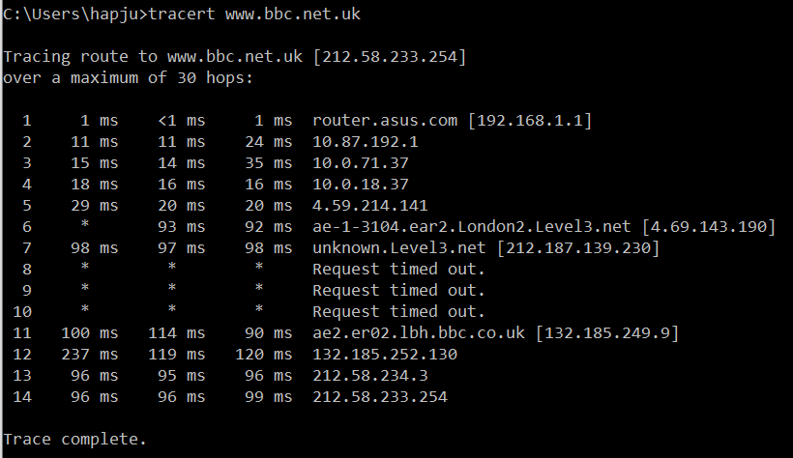
9:39
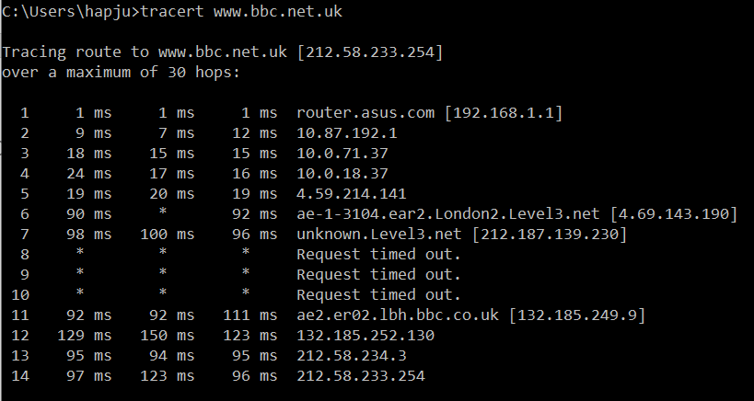
10:51pm
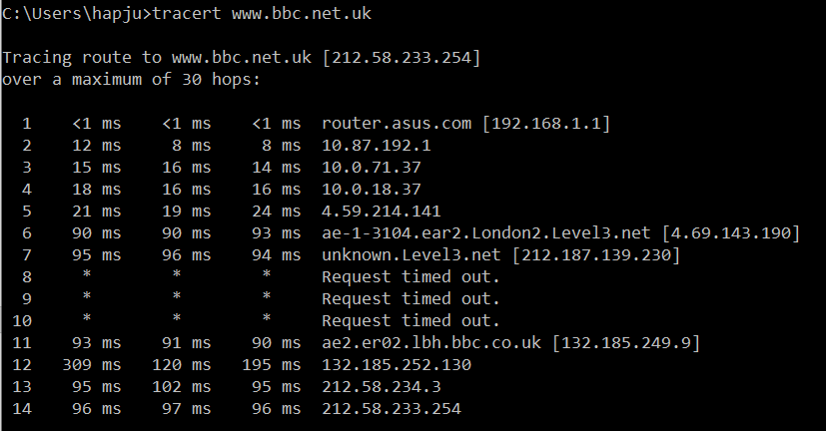

The averages (means) for the round-trip delays for hours 1, 2, and 3 are 97.0ms, 105.33ms, and 96.33ms (respectively).
$$µ_{1}=\frac{96+96+99}{3}=97.0ms$$
$$µ_{2}=\frac{97+123+96}{3}=105.33ms$$
$$µ_{3}=\frac{96+97+96}{3}=96.33ms$$
The standard deviations for the round-trip delays for hours 1, 2, and 3 are 1.414ms, 12.499ms, and 0.471ms (respectively).
$$σ_{1}=\sqrt{\frac{\left[{\left(96-97\right)}^{2}+{\left(96-97\right)}^{2}+{\left(99-97\right)}^{2}\right]}{3}}= \sqrt{\frac{1+1+4}{3}}=\sqrt{\frac{6}{3}}≅1.414ms$$
$$σ_{2}=\sqrt{\frac{\left[{\left(97-105.33\right)}^{2}+{\left(123-105.33\right)}^{2}+{\left(96-105.33\right)}^{2}\right]}{3}}= \sqrt{\frac{69.3889+312.2289+87.0489}{3}}=\sqrt{\frac{468.6667}{3}}≅12.499ms$$
$$σ_{3}=\sqrt{\frac{\left[{\left(96-96.33\right)}^{2}+{\left(97-96.33\right)}^{2}+{\left(96-96.33\right)}^{2}\right]}{3}}= \sqrt{\frac{0.1089+0.4489+0.1089}{3}}=\sqrt{\frac{0.6667}{3}}≅0.471ms$$

The number of routers in the path at each of the three hours is 14. No, the paths did not change between any of the traceroutes.

The number of ISP networks that the traceroute packages passed through in my experiments was approximately 6. Yes, it does appear that the largest delays occur at the peering interfaces between adjacent ISPs within my experiments.

2.

  - Consider the following string of ASCII characters that were captured by Wireshark when the browser sent an HTTP GET message (i.e., this is the actual content of an HTTP GET message).The characters <cr><lf> are carriage return and line-feed characters (that is, the italicized character string <cr> in the text below represents the single carriage-return character that was contained at that point in the HTTP header). Answer the following questions, indicating where in the HTTP GET message below you find the answer. [10]
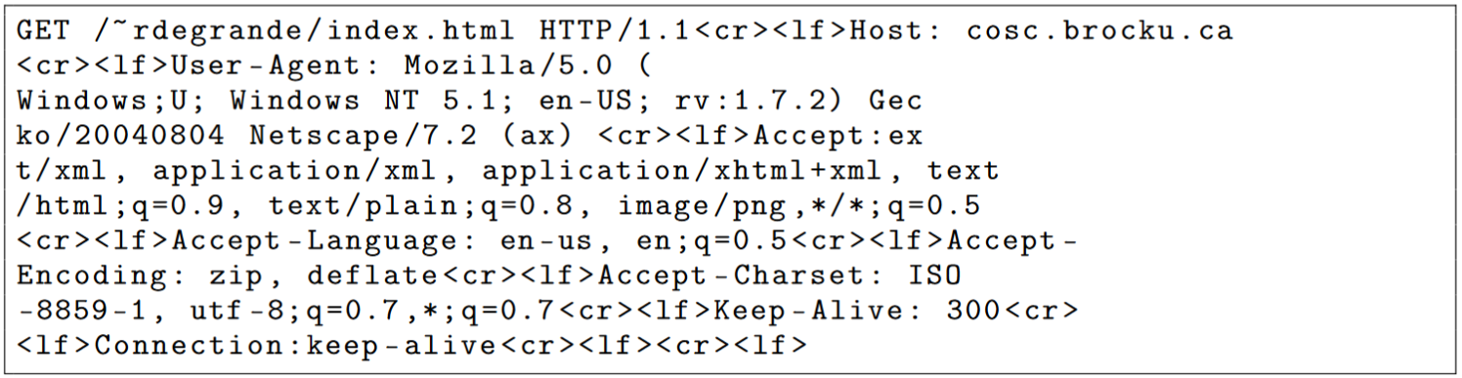
- What is the URL of the document requested by the browser?
The URL is “cosc.brocku.ca/~rdegrande/index.html” and is determined by combining the provided host name from line 1 with the resource path found after “GET” on line 1.
- What version of HTTP is the browser running?
The browser is running HTTP 1.1 which is seen in line 1: “HTTP/1.1”.

- Does the browser request a non-persistent or a persistent connection?
The browser requests a persistent connection as indicated by “Connection: keep-alive” in the final line.
- What is the IP address of the host on which the browser is running?
The IP address of the host is not specified within the content of a HTTP GET request, thus it cannot be determined without additional information.
- What type of browser initiates this message? Why is the browser type needed in an HTTP request message?
The type of browser is Netscape 7.2 as indicated on line 4. The browser type is needed in an HTTP request message so that the server may tailor its response to fit that browsers needs.

  - Suppose within your Web browser you click on a link to obtain a Web page. The IP address for the associated URL is not cached in your local host, so a DNS lookup is necessary to obtain the IP address. Suppose that n DNS servers are visited before your host receives the IP address from DNS; the successive visits incur an RTT of RTT₁, . . ., RTT_{n}. Further suppose that the Web page associated with the link contains exactly one object, consisting of a small amount of HTML text. Let RTT₀ denote the RTT between the local host and the server containing the object. [10]
- Assuming zero transmission time of the object, how much time elapses from when the client clicks on the link until the client receives the object?
Assuming zero transmission time, then the time required to get the IP will be ${\sum_{i=1}^{n}{RTT}}_{i}$. After the IP is known then the TCP connection must be established, taking RTT₀ time, after which the object must be requested and returned, also taking RTT₀ time. Thus, the total time that elapses between when the client clicks on the link to the client receiving the object is ${\sum_{i=1}^{n}{RTT}}_{i}+(2*RTT_{0})$.
- Suppose the HTML file references eight very small objects on the same server. Neglecting transmission times, how much time elapses with non-persistent HTTP with no parallel TCP connections?
The IP will be retrieved in ${\sum_{i=1}^{n}{RTT}}_{i}$ time.
The HTML file will be retrieved in $2*RTT_{0}$ time.
Each of the 8 objects will then require a new TCP connection to be established and before being requested and returned, taking $2RTT_{0}$ time each.
Thus, the total elapsed time is:
${\sum_{i=1}^{n}{RTT}}_{i}+\left(2*RTT_{0}\right)+8*\left(2*RTT_{0}\right)= {\sum_{i=1}^{n}{RTT}}_{i}+\left(18*RTT_{0}\right)$.
- Suppose the HTML file references eight very small objects on the same server. Neglecting transmission times, how much time elapses with Non-persistent HTTP with the browser configured for 5 parallel connections?
The IP will be retrieved in ${\sum_{i=1}^{n}{RTT}}_{i}$ time.
The HTML file will be retrieved in $2*RTT_{0}$ time.
5 parallel connections means that up to 5 objects can be requested and returned at a time, thus we can request and retrieve 5 of the objects in parallel, then request and retrieve the remaining 3 objects in parallel, taking $2*RTT_{0}+2*RTT_{0}$ time.
Therefore, the total elapsed time is:
${\sum_{i=1}^{n}{RTT}}_{i}+\left(2*RTT_{0}\right)+2*\left(2*RTT_{0}\right)= {\sum_{i=1}^{n}{RTT}}_{i}+(6*RTT_{0})$.
- Suppose the HTML file references eight very small objects on the same server. Neglecting transmission times, how much time elapses with Persistent HTTP?
The IP will be retrieved in ${\sum_{i=1}^{n}{RTT}}_{i}$ time.
The HTML file will be retrieved in $2*RTT_{0}$ time.
All 8 objects will be retrieved without the need to establish a new TCP connection or request the objects individually, taking $RTT_{0}$ time.
Therefore, the total elapsed time is:
${\sum_{i=1}^{n}{RTT}}_{i}+\left(2*RTT_{0}\right)+RTT_{0}= {\sum_{i=1}^{n}{RTT}}_{i}+(3*RTT_{0})$.

  - Consider distributing a file of F=15 Gbits to N peers. The server has an upload rate of u_{s}=30Mbps, and each peer has a download rate of d_{i}=2 Mbps and an upload rate of u. For N=10, 100, and 1,000 and u=300 Kbps, 700 Kbps, and 2 Mbps, prepare a chart giving the minimum distribution time for each of the combinations of N and u for both client-server distribution and P2P distribution. [10]

Note: d_{min} = min client download rate = d_{i}
Note: 1 Gbps = 1024 Mbps
Note: 1 Mbps = 1024 Kbps

Client Server Distribution:
Formula: $D_{c-s}≥\max\left(\frac{NF}{u_{s}},\frac{F}{d_{min}}\right)$

 |  | u
 |  | 300 Kpbs | 700 Kbps | 2 Mbps
N | 10 | $$\max\left(\frac{10*15360}{30},\frac{15360}{2}\right)=\max\left(5120,7680\right)$$  $$=7680$$ | $$\max\left(\frac{10*15360}{30},\frac{15360}{2}\right)=\max\left(5120,7680\right)$$  $$=7680$$ | $$\max\left(\frac{10*15360}{30},\frac{15360}{2}\right)=\max\left(5120,7680\right)$$  $$=7680$$
N | 100 | $$\max\left(\frac{100*15360}{30},\frac{15360}{2}\right)=\max\left(51200,7680\right)$$  $$=51200$$ | $$\max\left(\frac{100*15360}{30},\frac{15360}{2}\right)=\max\left(51200,7680\right)$$  $$=51200$$ | $$\max\left(\frac{100*15360}{30},\frac{15360}{2}\right)=\max\left(51200,7680\right)$$  $$=51200$$
N | 1000 | $$\max\left(\frac{1000*15360}{30},\frac{15360}{2}\right)=\max\left(512000,7680\right)$$  $$=512000$$ | $$\max\left(\frac{1000*15360}{30},\frac{15360}{2}\right)=\max\left(512000,7680\right)$$  $$=512000$$ | $$\max\left(\frac{1000*15360}{30},\frac{15360}{2}\right)=\max\left(512000,7680\right)$$  $$=512000$$

P2P Distribution:
Formula: Formula: $D_{P2P}≥\max\left(\frac{F}{u_{s}},\frac{F}{d_{min}},\frac{NF}{u_{s}+\sum{u_{i}}}\right)$

 |  | u
 |  | 300 Kpbs | 700 Kbps | 2 Mbps
N | 10 | $$\max\left(\frac{15360}{30},\frac{15360}{2},\frac{10*15360}{30+(10*\frac{300}{1024})}\right)=\max\left(512,7680,4664.48\right)$$  $$=7680$$ | $$\max\left(\frac{15360}{30},\frac{15360}{2},\frac{10*15360}{30+(10*\frac{700}{1024})}\right)=\max\left(512,7680,4169.84\right)$$  $$=7680$$ | $$\max\left(\frac{15360}{30},\frac{15360}{2},\frac{10*15360}{30+(10*2)}\right)=\max\left(512,7680,3072\right)$$  $$=7680$$
N | 100 | $$\max\left(\frac{15360}{30},\frac{15360}{2},\frac{100*15360}{30+(100*\frac{300}{1024})}\right)=\max\left(512,7680,25903.56\right)$$  $$=25904$$ | $$\max\left(\frac{15360}{30},\frac{15360}{2},\frac{100*15360}{30+(100*\frac{700}{1024})}\right)=\max\left(512,7680,15616.20\right)$$  $$=15616$$ | $$\max\left(\frac{15360}{30},\frac{15360}{2},\frac{100*15360}{30+(100*2)}\right)=\max\left(512,7680,6678.26\right)$$  $$=7680$$
N | 1000 | $$\max\left(\frac{15360}{30},\frac{15360}{2},\frac{1000*15360}{30+(1000*\frac{300}{1024})}\right)=\max\left(512,7680,47558.78\right)$$  $$=47559$$ | $$\max\left(\frac{15360}{30},\frac{15360}{2},\frac{1000*15360}{30+(1000*\frac{700}{1024})}\right)=\max\left(512,7680,21524.85\right)$$  $$=21525$$ | $$\max\left(\frac{15360}{30},\frac{15360}{2},\frac{1000*15360}{30+(1000*2)}\right)=\max\left(512,7680,7566.50\right)$$  $$=7680$$

3.

  - UDP and TCP use 1s complement for their checksums. [10]
- Suppose you have the following 2 bytes: 01011100 and 01100101. What is the 1s complement of the sum of these 2 bytes?
11111
01011100
+ 01100101
------------------
11000001 -> 00111110

Therefore, the ones complement of the sum of these two bytes is 00111110.
- Suppose you have the following 2 bytes: 11011010 and 01100101. What is the 1s complement of the sum of these 2 bytes?
1
11011010
+ 01100101
------------------ 1111111
00111111 -> 00111111
---------------
01000000 -> 10111111

Therefore, the ones complement of the sum of the two bytes us 10111111.

- For the bytes in part (a), give an example where one bit is flipped in each of the 2 bytes and yet the 1s complement doesn’t change.
11111 11111
01011100 01011101
+ 01100101 + 01100100
------------------ ------------------
11000001 11000001 -> 00111110

Therefore, flipping the last bit in each of the two bytes from part (a) produces the same ones complement sum.

  - Compare GBN, SR, and TCP (no delayed ACK). Assume that the timeout values for all three protocols are sufficiently long such that 5 consecutive data segments and their corresponding ACK scan be received (if not lost in the channel) by the receiving host (Host B) and the sending host (Host A) respectively. Suppose Host A sends 5 data segments to Host B, and the 2nd segment (sent from A) is lost. In the end, all 5 data segments have been correctly received by Host B. [15]
- How many segments has Host A sent in total and how many ACKs has Host B sent in total? What are their sequence numbers? Answer this question for all three protocols.
GBN: Host A initially sends 5 data segments. Since the 2nd data segment is lost, B only ACK’s segment 1, thus data segments 2 through 5 are retransmitted. Host BThus, Host A sends 9 data segments in total and Host B sends 8 ACKs.

